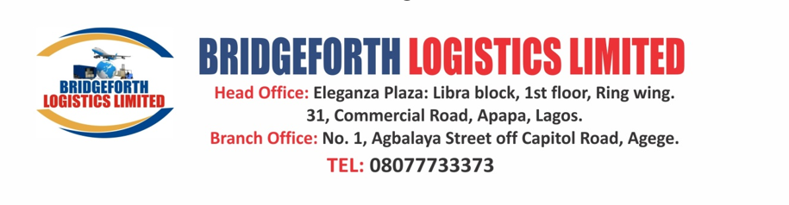

**Proforma Invoice**

30/01/2025
Emjal Pharmacy
Lagos Nigeria.

**Invoice Number:** MT08/2025
**Date:** 30th January 2025
**Payment Terms:** 80% Advance and 20% to be paid at arrival

S/N | Description of Products | Quantity | Packing Style | Per Unit USO Price | factory Total price usd | FREIGHT CHARGE | Total Usd CIF
1 | Sodium BP 75 Mg & Misoprostol USP 200 | 5000 | 10x10 | 4.76 | 18,400 | 2200 | 23,800

**Notes:**
1. Prices are inclusive of freight and clearing charges
2. We will clear and hand over .
3. 80% Payment must be made in full before shipment.

Authorized Signature:

Rajesh Mukot Vallapile
CEO
Bridgeforth Logistics Limited
+234 8027437988
meditreat.limited@gmail. com

